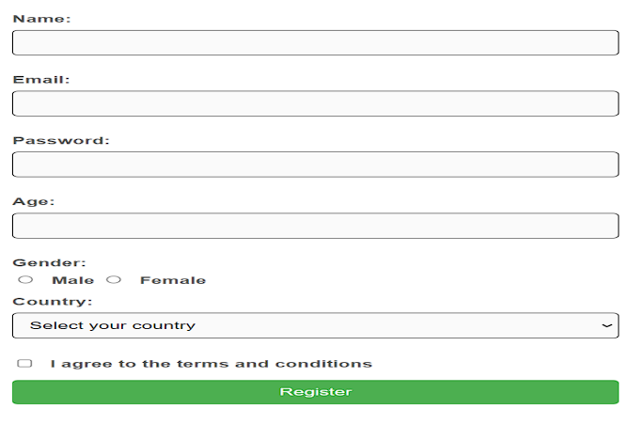
HTML Code

<!DOCTYPE html>
<html lang="en">
<head>
<meta charset="UTF-8">
<meta name="viewport" content="width=device-width, initial-scale=1.0">
<title>Registration Form</title>
<style>
body {
font-family: Arial, sans-serif;
background-color: #f0f0f0;
}
.container {
max-width: 400px;
margin: 0 auto;
padding: 20px;
background-color: #ffffff;
border-radius: 8px;
box-shadow: 0 2px 4px rgba(0, 0, 0, 0.1);
}
h1 {
text-align: center;
color: #333;
}
label {
display: block;
margin-bottom: 8px;
font-weight: bold;
}
input[type="text"],
input[type="email"],
input[type="password"] {
width: 100%;
padding: 10px;
margin-bottom: 20px;
border: 1px solid #ccc;
border-radius: 4px;
}
input[type="radio"] {
margin-right: 10px;
}
select {
width: 100%;
padding: 10px;
margin-bottom: 20px;
border: 1px solid #ccc;
border-radius: 4px;
}
input[type="checkbox"] {
margin-right: 10px;
}
button {
width: 100%;
padding: 10px;
background-color: #007bff;
color: #ffffff;
border: none;
border-radius: 4px;
cursor: pointer;
}
button:hover {
background-color: #008000;
}
</style>
</head>
<body>
<div class="container">
<h1>Registration Form</h1>
<form>
<label for="name">Name:</label>
<input type="text" id="name" placeholder="Enter your name" required>
<label for="email">Email:</label>
<input type="email" id="email" placeholder="Enter your email" required>
<label for="password">Password:</label>
<input type="password" id="password" placeholder="Enter your password" required>
<label>Gender:</label>
<input type="radio" id="male" name="gender" value="male">
<label for="male">Male</label>
<input type="radio" id="female" name="gender" value="female">
<label for="female">Female</label>
<label for="country">Select your country:</label>
<select id="country">
<option value="usa">USA</option>
<option value="canada">Canada</option>
<option value="uk">UK</option>
</select>
<input type="checkbox" id="terms" required>
<label for="terms">I agree to the terms and conditions</label>
<button type="submit">Register</button>
</form>
</div>
</body>
</html>

